Lizzy Hanna

CSE 3342-001

2/2/19

**Assignment 1**

**Python Program:**

#Lizzy Hanna, CSE 3342 Assignment 1, ID 47358250

#recursive function that converts decimal to its equivalent of any base

#when base is 2=binary, 3=ternary, 4=quarternary, 8=octal

def convert_decimal(decimal_value, base):

if(decimal_value>1):

convert_decimal(decimal_value//base, base)

print(decimal_value%base, end='') #prints remainder

#converts decimal to hex

def convert_to_hex(decimal_value):

if(decimal_value > 1):

convert_to_hex(decimal_value//16) #recursive call, passes in dividend

hex_value = decimal_value % 16

if(hex_value > 9): #if number is not decimal, convert to letter equivalent

if(hex_value == 10):

print("A", end='')

elif(hex_value == 11):

print("B", end='')

elif(hex_value == 12):

print("C", end='')

elif(hex_value == 13):

print("D", end='')

elif(hex_value == 14):

print("E", end='')

elif(hex_value == 15):

print("F", end='')

else:

print(hex_value, end='')

#converts binary to decimal

def convert_to_decimal(binary_value):

decimal = 0

i = 0

digit = 0

while(binary_value != 0):

digit = binary_value % 10

decimal = decimal + digit * pow(2, i)

binary_value = binary_value//10

i+= 1

return decimal

#accepts a decimal value from the user to be converted

while True:

try:

decimal_value = int(input("Enter a positive decimal value to display to: "))

except ValueError:

print("Error: Please enter a positive decimal value.")

else:

for i in str(decimal_value):

if i in '1234567890':

decimal = True

else:

decimal = False

break

if decimal == False:

print("Please enter a positive decimal value.")

else:

break

print("Binary: ", end='')

convert_decimal(decimal_value, 2)

print("")

print("Ternary: ", end='')

convert_decimal(decimal_value, 3)

print("")

print("Quarternary: ", end='')

convert_decimal(decimal_value, 4)

print("")

print("Octal: ", end='')

convert_decimal(decimal_value, 8)

print("")

print("Hex: ", end='')

convert_to_hex(decimal_value)

print("")

#accepts a binary value from the user to be converted

while True:

try:

binary_value = int(input("Enter binary value to display to: "))

except ValueError:

print("Error: Enter a binary value to display to:")

#checks to make sure that the number entered is binary (made of 1s and 0s)

else:

for j in str(binary_value): #converts to string

if j in '10': #looks for 1 or 0 in string

binary = True

else:

binary = False #the number is not made entirely of 1 and 0, not binary

break

if binary == False:

print("Please enter a binary number.")

else:

break

#turns binary number into decimal to use in all future conversions

decimal_value = convert_to_decimal(binary_value)

print("")

print("Ternary: ", end='')

convert_decimal(decimal_value, 3) #decimal to ternary

print("")

print("Quarternary: ", end='')

convert_decimal(decimal_value, 4) #decimal to quarternary

print("")

print("Octal: ", end='')

convert_decimal(decimal_value, 8) #decimal to octal

print("")

print("Decimal: ", decimal_value) #prints decimal value calculated in line 100

print("Hex: ", end='')

convert_to_hex(decimal_value) #decimal to hex

print("")

**Output:**

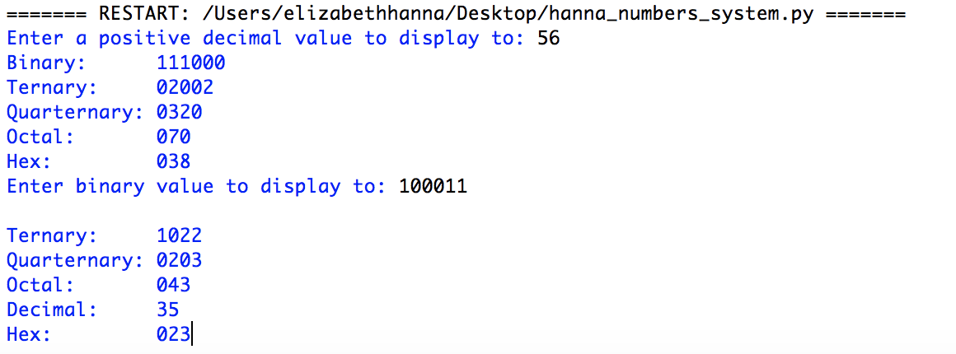

**Test Cases:**

* Test Case 1:
  + Decimal: 0, Binary: 0
  + Output:

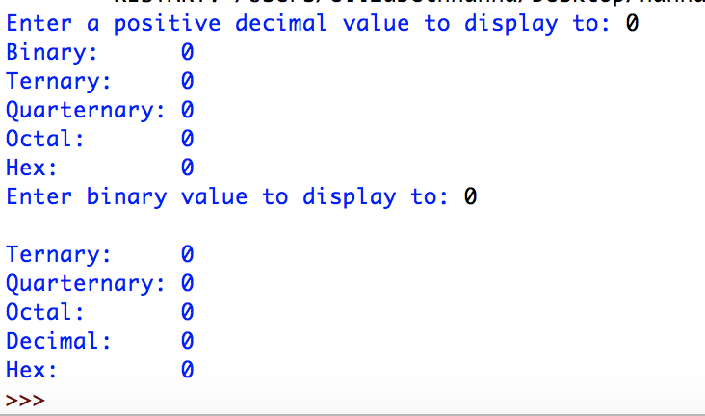

* Test Case 2:
  + Decimal: 10, Binary: 1010
  + Output:

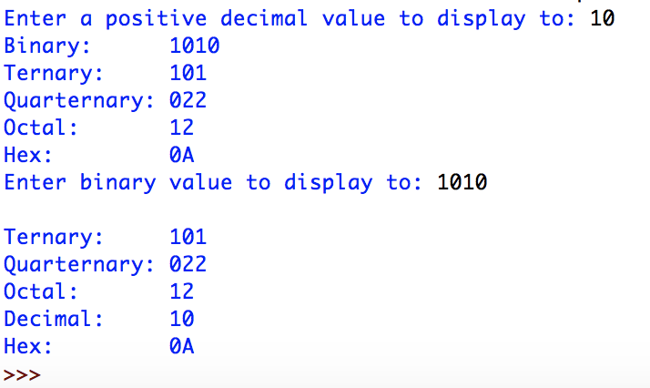

* Test Case 3:
  + Decimal: 10000, Binary: 10011100010000
  + Output:

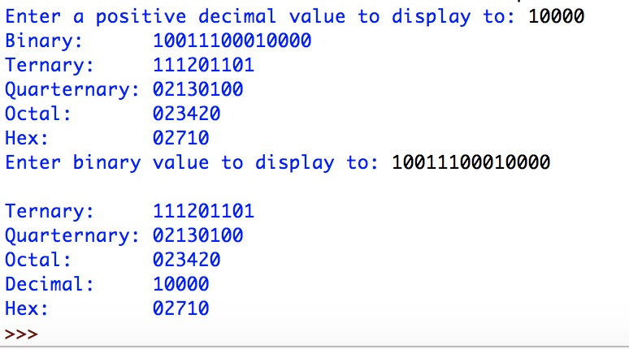

* Test Case 4:
  + Decimal: -1, Binary: -1
  + Output:

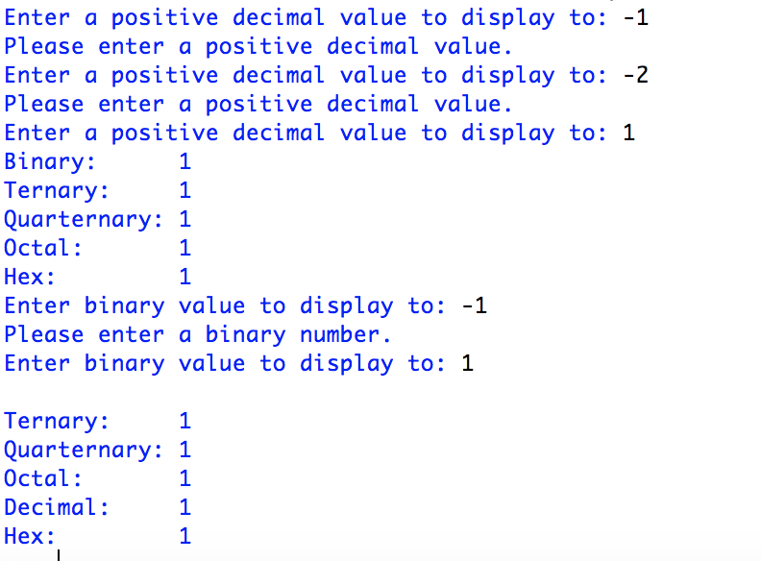

* Test Case 5:
  + Decimal: A, Binary: A
  + Output:

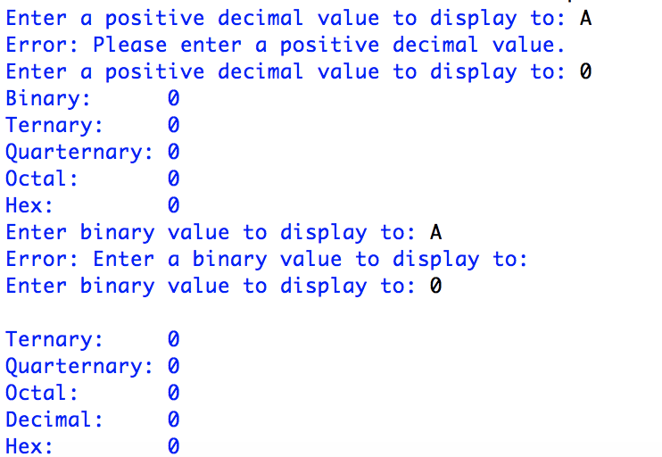

* Test Case 6:
  + Decimal: 50, Binary: 50
  + Output:

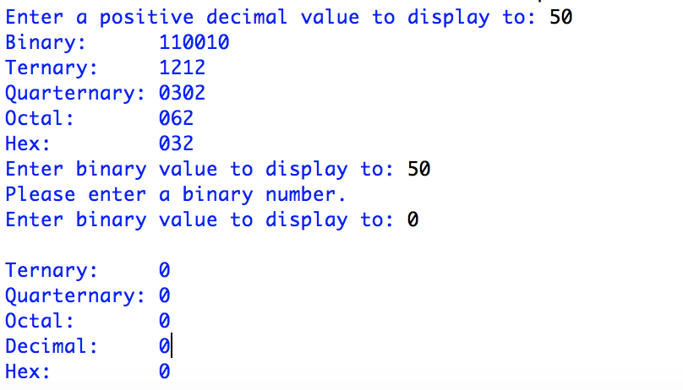

* Test Case 7:
  + Decimal: 700, Binary: 700
  + Output:

